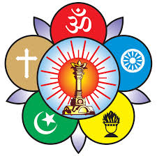
Sri Sathya Sai Seva Organisations- India
Diploma in
Sri Sathya Sai
Leadership
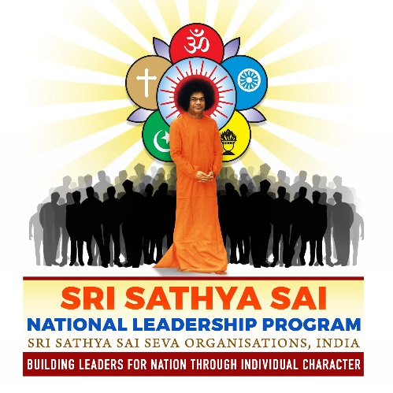

In Association With
Sri Sathya Sai Institute of Higher Learning , Puttaparthi
( DEEMED TO BE UNIVERSITY)

Background & Context

Aim is to conduct a value based, character oriented diploma course, which will cater to graduating or just graduated college students. While empowering the participants with key everyday professional skills, we will also be highlighting the importance of Individual and National Character, the need for social responsibility (i.e. servitude)… all built on a solid foundation of Self Mastery. Through this program, the Sai Organisation wishes to spread Bhagawan Sri Sathya Sai Baba varu’s message, and create an awareness amongst the emerging youth leaders about their responsibilities to self and the nation.

Program Overview
Diploma in Sri Sathya Sai Leadership and Human Values (SSSLHV) will be a national level, web based, online program. Web Conferencing technology “WebEx “ will be used for this purpose. The program is expected to be conducted on Saturdays and will take six months to complete. The medium of presentations will be English. Each session is expected to last only 90 minutes. However, there will be some pre and post session activities involving such things as reading, reflecting, watching videos and doing other home-work activities. While most of the session is web based, there will also be a three day in-house session held in Prashanti Nilayam, Puttaparthi. The six month program will culminate in a real-life, hands-on project which will not only focus on the participants local issues, but will also give the participant an opportunity to practice all their learnings. Finally, the closure of the program will be a in-person graduation ceremony, held in Prasanthi Nilayam, Puttaparthi.
The SSSLHV program has 4 core components:
- Part 1 will focus on Individual Skills
- Part 2 will focus on Group Skills
- Part 3 will focus on Individual Unfoldment
- Part 4 will focus on Value based Leadership

Timeline
This is an web based, online program , lasting for about 26 weeks, with 3 days induction program by the Sri Sathya Sai Institute of Higher Learning ,Puttaparthi on March 6-8, 2020 and a 2 day culmination and grad walk in Prashanthi Nilayam. The online program is offered on Saturdays at 7:30pm, with each session lasting 90 minutes. Mode of instruction would be English.

Participants
Maximum number of participants is expected to be 200. Each state in India will be offered ten seats each, where half are expected to existing Sai Youth, and the remaining half will be for outside youth.

Topics covered:

Part 1 - Individual Skills

GoalSetting Module
- working with a vision helps channelize energy, resources, effort
- what kind of goals to set
- tasks list, planning, prioritising

Communication / Intro to business communication Part 1, Part 2
- Importance of listening
- Direct Vs Indirect
- ability to articulate things (mind maps, 5w1h technique)
- raising risks
- speaking about problems & offering solutions
- service mindset for customers

Communication / Written communication
- emailing etiquette
- responsiveness
- Do’s & Dont's

Time Management
- Important but not urgent
- planning, prioritising
- tradeoffs

Executive Presence
- Dressing for Corporate (and not fashion, party)
- Executive Language & behaviour - coming across as a professional

Part 2 - Team / Group Skills

Corporate Meetings
- purpose & roles of mtgs in corporate
- roles & responsibilities

Being a good team player
- What are teams
- What does it mean to be a team player
- Dealing / handling boss
- Dealing / handling peers

Project Management
- planning, execution and follow-up
- documentation
- monitoring, tracking, reporting

Part 3 – Self Mastery
Intent of Self Mastery module is to enable the Young Leader to stabilise the foundation of Self Leadership, in line with Swami’s guideline that “ The one who is a Sreshta (Leader) needs to exemplify the Leadership in Action first). The various topics under this Module are briefly discussed here:
- Topic # 1: Self Awareness :
- Topic # 2: Self-Regulation:
- Topic # 3: Self Discovery Tools:

Part 4 : Values and Ethics
The intent of this module is to make participant more sensitive and aware of the need for Values and Ethics in their day to day (professional) life, and to share the life and teachings of Bhagawan Sri Sathya Sai Baba varu. This part of the module will be handled by experts from Prasanthi Nilayam and across the country .

Part 5 - Project and Submission of Report
A in-house session will be held in Prashanti Nilayam where students will share their project reports, network amongst themselves and discuss next steps. The program will end with a “Graduation Walk” ceremony.

